Patient Information:
Today’s Date: / /_

Patient Name (Last, First, M.I.): _______
Birth Date: / / Age: Sex: Male Female
Address: City: State: Zip Code: Home Phone: ( )___ Cell/Alternate Phone: ( _)___ __
E-Mail: ____________________________________________
Employer: Work Phone: Can We Contact You Here? _Yes _No
Name of Spouse/Partner or Guardian (if underage): Birth Date: /_ /_ Emergency Contact: Relationship: Phone #:
How did you hear about us?
Who is your primary care physician? _______________________________ Group____________________________________

Insurance Information:

Please allow us to make a copy of your insurance identification card

Name Of Primary Insurance: Group/Account #:_ Policy #:_ Policy Holder’s Name: Birth Date: / /
Patient’s Relationship to Policy Holder: _Self _Spouse _Child _Other_
*Name Of Secondary Insurance: (*If Applicable) Group/Account #: Policy #:
Policy Holder’s Name: Birth Date: / /

Patient’s Relationship to Policy Holder: _Self _Spouse _Child _Other_

Billing Information:
(If self, leave blank)

Person Responsible For Bill:

Birth Date: / /_

Address (If Different): City: State: Zip Code: Home Phone #:

The above information is true to the best of my knowledge. I authorize my insurance benefits to be paid directly to the physician.

I understand that I am financially responsible for any balance. I also authorize the above listed clinic or insurance company to release any information required to process my claims.
Signature (Guardian if underage):_ Date:

Office Policies Regarding: Personal Health Insurance & Private Payment

1) For your convenience we will verify your insurance benefits and submit claims as a courtesy to you. However, your insurance is a contract between you and your insurance company, NOT between Greece Chiropractic and your insurance company. You are fully responsible for all charges due to services rendered. If payment is denied for any reason by your insurance company, you are then responsible for full payment of those services rendered.
2) All charges must be paid at the time of services. This includes co-pays and deductibles. We accept payment in the form of cash, check and credit/debit card. Returned checks are subject to a $20 fee.
3) Any insurance payments that have been paid directly to you by your insurance company must be received by

Greece Chiropractic no later than one week from receipt and endorsed to this clinic.

4) Please make payments on time. If you experience financial difficulties, please call us. We will do our best to work out a payment plan. If balances are not paid within 90 days from the time of first statement, and arrangements for payment have not been made, your account will be referred for legal action.
I have read, understand, and accept the insurance/payment policy at Greece Chiropractic.

Patient Signature: Date:

_ _ _ _ _ _ _ _ _ _ _ _ _ _ _ _ _ _ _ _ _ _ _ _ _ _ _ _ _ _ _ _ _ _ _ _ _ _ _ _ _ _ _ _ _ _ _ _ _ _

Medical Records/Consent to treatment/HIPPA and privacy policies

I authorize Greece Chiropractic to release any information in the event my insurance company/attorney requests records or information related to my treatment at your office. I also authorize Greece Chiropractic to obtain on my behalf information, including but not limited to, provider chart notes, lab or imaging reports, and copies of films.
I am at Greece Chiropractic to be evaluated and treated for my current condition. I understand that my diagnosis and treatment will be discussed with me and that I will have the opportunity to ask questions regarding both, prior to treatment. Therefore, I consent to both evaluation and treatment by the doctors. Please see the form attached to the clipboard given to you. You may have a copy for your records by simply asking the front desk. I have received, read, and understand the privacy policies, consent to treatment, and medical records policies of Greece Chiropractic.
Patient Signature: Date:

_ _ _ _ _ _ _ _ _ _ _ _ _ _ _ _ _ _ _ _ _ _ _ _ _ _ _ _ _ _ _ _ _ _ _ _ _ _ _ _ _ _ _ _ _ _ _ _ _ _

Consent to Treat a Minor

I, (parent/guardian) give my permission to the providers at Greece Chiropractic to give spinal adjustment/manipulations and necessary therapies to
(child’s name).

Parent/Guardian Signature: Date:

Please draw in where you are experiencing your problem

Patient Health Questionnaire

1. Symptoms began on:

2. Briefly describe your symptoms:

3. How did your symptoms start? _

4. Average pain intensity:

a. Last 24 hours: (no pain) 1 2 3 4 5 6 7 8 9 10 (worst pain)

b. Past week: (no pain) 1 2 3 4 5 6 7 8 9 10 (worst pain)
FOR OFFICE USE
O= _____________ *__________________
Pall=____________________________________
Prov=___________________________________
R= _____________________________________
T=______________________________________
MVA Info: _______________________________
5. How often do you experience your symptoms?

1 – Constant (76-100% of time) 2 – Frequent (51-75% of time)
3 – Occasional (26-50% of time) 4 – Intermittent (0-25% of time)

6. How much have your symptoms interfered with your daily activities?
(Including both work outside the home and housework)

1 – Not at all 2 – A little bit 3 – Moderately 4 – Quite a bit 5 – Extremely

7. How are your symptoms changing?

1 – Getting Better 2 – Not Changing 3 – Getting Worse

8. In general, how is your overall health right now?

1 – Excellent 2 – Very Good 3 – Good 4 – Fair 5 – Poor

9. Have you seen anyone else for your symptoms? 1 – Yes 2 – No

If “yes”, who and what treatment?

10. Past/Present Health History (Please indicate any other health conditions past or present in the area below.)

_ Headaches

_ Stroke

_ Asthma

_ Back Pain

_ Heart Attack

_ Shortness of Breath

_ Neck Pain

_ Heart Disease

_Other: ______________

_ Depression

_ Joint Pain

_ High Blood Pressure

_ General Fatigue

_ Arthritis

_ Sinus Problems/Allergies

_ Weight Loss/Gain

_ Kidney Disorders

_ Dizziness

_ Cancer/Tumor

_ Bladder/ Bowel Change

_ Diabetes

_ Smoking/Tobacco Use

_ Excessive Thirst

_ Drug/Alcohol

Dependence

_ Digestion Problems

_ Frequent Urination

_ Birth Control Pills

(Female Only)

_ Stomach Pain

_ Prostate Problems

_ Pregnancy (Female

Only)

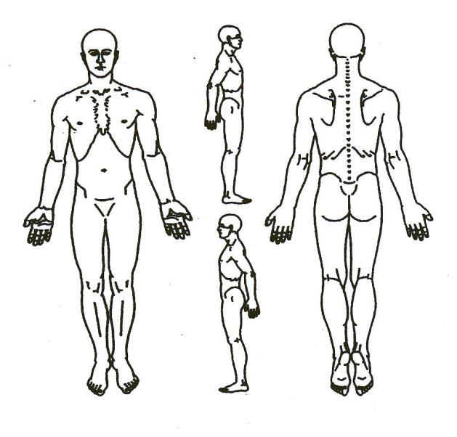

11. List all prescription and over-the-counter medications, and nutritional/herbal supplements you are taking:

12. List all surgical procedures and hospitalizations:

Patient Signature: Date:

